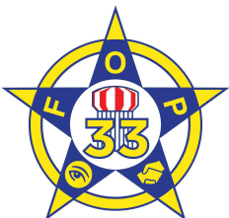

Inside This Issue

1. New Associate Lodge

1 New Website

2 Fall KY FOP Conference

2 Revised Bylaws Approved

2 New Lodge Home

3 State Legislative Updates

4 E-Board Elections

4 Upcoming Events

# New Website

Keep up to date with the lodge between newsletters by visiting our new website [www.florencefop33.org](http://www.florencefop33.org).

A dedicated member’s area contains information pertinent to our members. We also have several public pages to share the good work of our members and of Lodge 33 in the community.

# New Associate Lodge

The Executive Board for the Florence Police Lodge #33, Fraternal Order of Police is excited to announce that we are recruiting interested persons to join us in the establishment of the new Fraternal Order of Police Associate (FOPA) Lodge #33. The FOPA is the civilian affiliate of the Fraternal Order of Police Lodge #33, both located in Florence, Kentucky.

Members of the FOPA are friends and families of law enforcement officers, responsible and respected business persons, professional men and women, and citizens from all walks of life. People willing to devote a portion of their time and efforts toward assisting the various law enforcement agencies of our communities, states and nation.

More information as well as our application can be found or online here:

[FOP Shared Dropbox Folder](https://www.dropbox.com/sh/eay7ssmk21t6k7a/AACBPcjKhN0RnztqM9vSG8k3a?dl=0)

**Regular Monthly Meeting Date**

3rd Monday

7:00 p.m.

# Welcome to Our Newsletter

In an effort to ensure our members are up to date on the work being done by the FOP on the local, state and national level, Florence Lodge #33 is happy to introduce you to our new newsletter.

This newsletter will be distributed on a regular basis to include information of interest to our membership. The Executive Board of Lodge #33 hopes this increased communication will help us to make the lodge stronger, increase participation by our membership, help our members get the most out of their membership, and help us increase the positive impact we have on our community.

A great deal of work has been done recently and there is even more to be done. We look forward to working with all of our members to further the mission of the FOP while we build an even stronger lodge,

Florence

FOP Lodge #33 Newsletter

volume 1 issue 1



9/22/20

Would you like to help with future editions of this newsletter?

Contact Chris McGreevy

2020 Executive Board

Kevin Duncan, President

Pat Cottingham,   
Vice President

Chris McGreevy,   
2nd Vice President

Zach Eagler, Treasurer/Secretary

Robert Fulton,   
State Trustee

Ethan Manley,   
Sergeant at Arms

Nick Houlehan,  
Chaplain

# Revised Bylaws Approved

# Fall 2019 Kentucky FOP Conference

The Executive Board recently revised the Lodge #33 Constitution and Bylaws. Several area lodges as well as the State Lodge provided examples to help us bring our Constitution up to current standards. The State Constitution and Bylaws committee recommended to accept our revisions at the Fall Conference, which was approved by the membership. The revised bylaws are available here: [FOP Shared Dropbox Folder](https://www.dropbox.com/sh/eay7ssmk21t6k7a/AACBPcjKhN0RnztqM9vSG8k3a?dl=0)

**Rob Fulton**, Florence Lodge #33 State Trustee

**Tim Jones**, Boone Lodge #46 President

**Spike Jones** KY State FOP Immediate Past President

Members of Lodge #33 attended the Fall Kentucky State FOP Conference in November 2019 which took place at the Radisson in Covington. The Fall Conference was hosted by several Northern Kentucky Lodges including Covington Lodge 1, Kenton Lodge 20, Campbell Lodge 10, Kenton County Police Lodge 44 and Florence Lodge 33. Members of Lodge 33 helped in the planning of the Conference including securing sponsors for the Hospitality Room, which was a huge success.



# New Lodge Home

In January, Lodge #33 moved to a new home. The space which we have occupied for around 15 years is being repurposed by our new landlord, which prompted a move to another space in the building. Thought the new space is smaller, it provides us with several rooms, including a kitchen area with a sink, and soon a stove. Work is being done to finish setting up the space but once completed, it will again be available for use by our members. Contact any E-board member to get the electronic lock code for access.

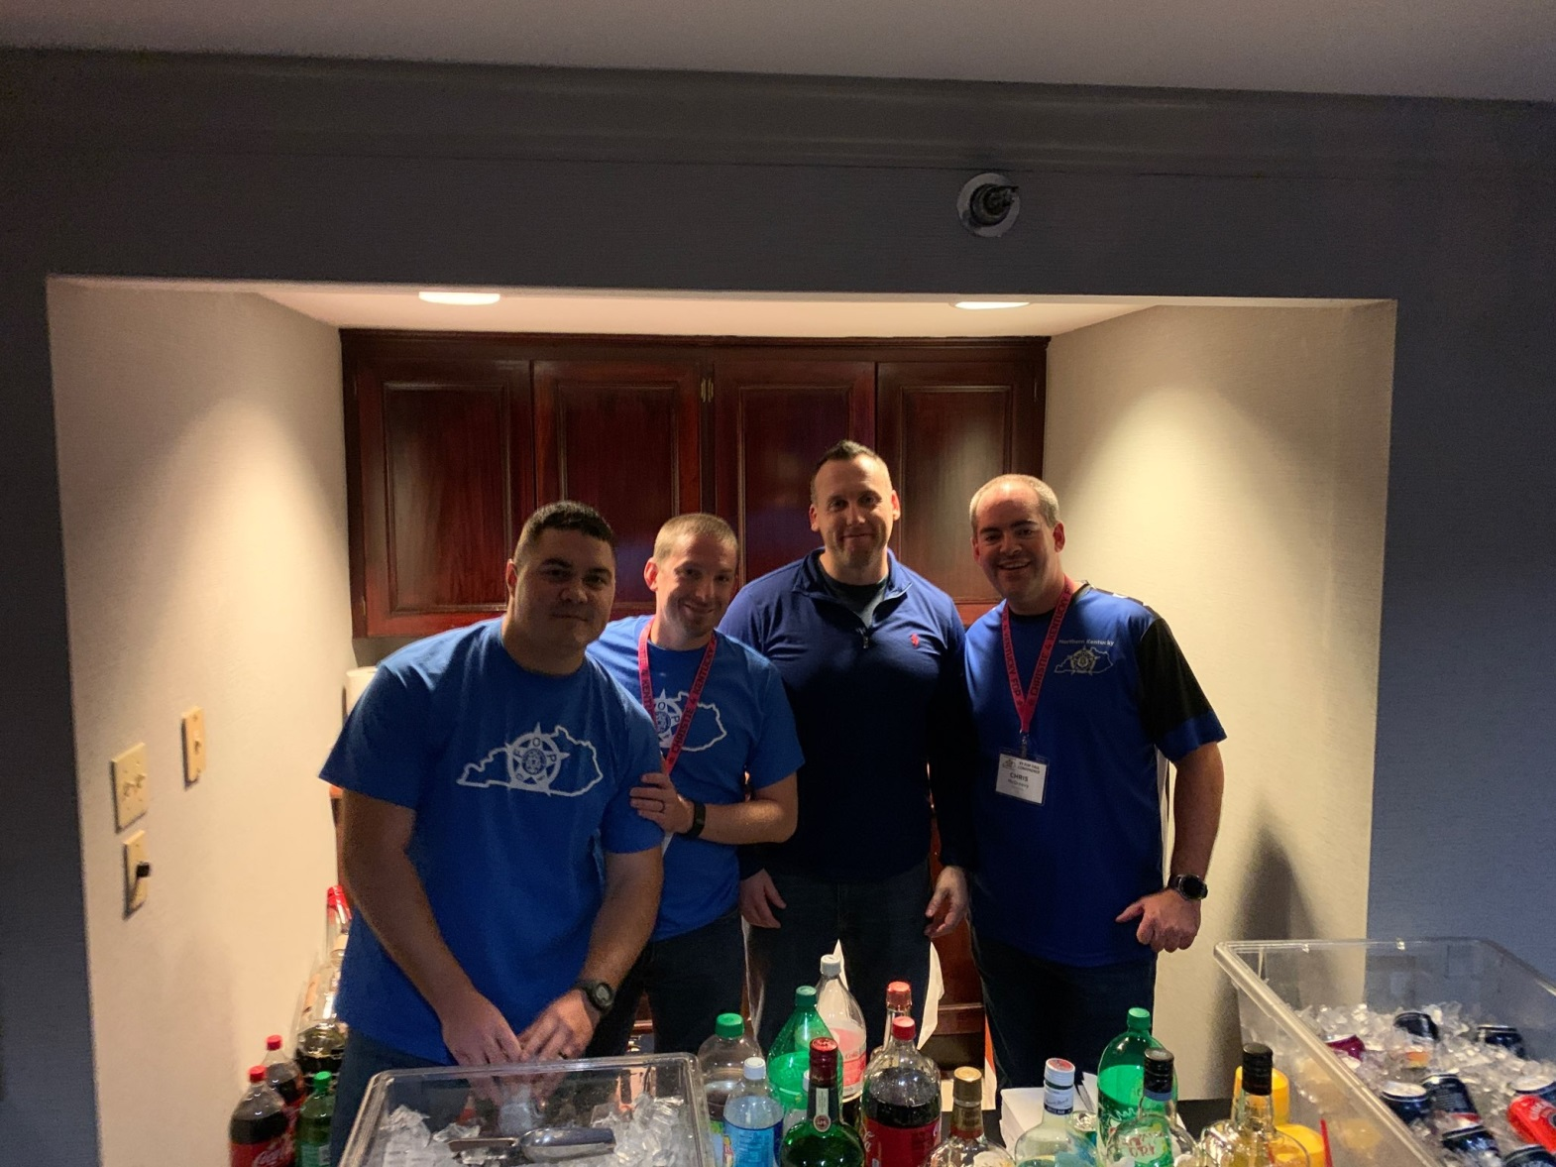

**Standing Committees**

Constitution and Bylaws

Elections

Screening Committee

Political Endorsement

Grievance Committee

- If interested in serving on any committee, contact Kevin Duncan or Pat Cottingham

Lodge #33 members working the hospitality room at the Fall State FOP Conference 2019

The KY State FOP regularly publishes a State Legislative Update. This update is emailed monthly and you can subscribe by visiting the KY State FOP website at [kystatefop.com](http://kystatefop.com) and click “Constant Contact – Sign Up”.

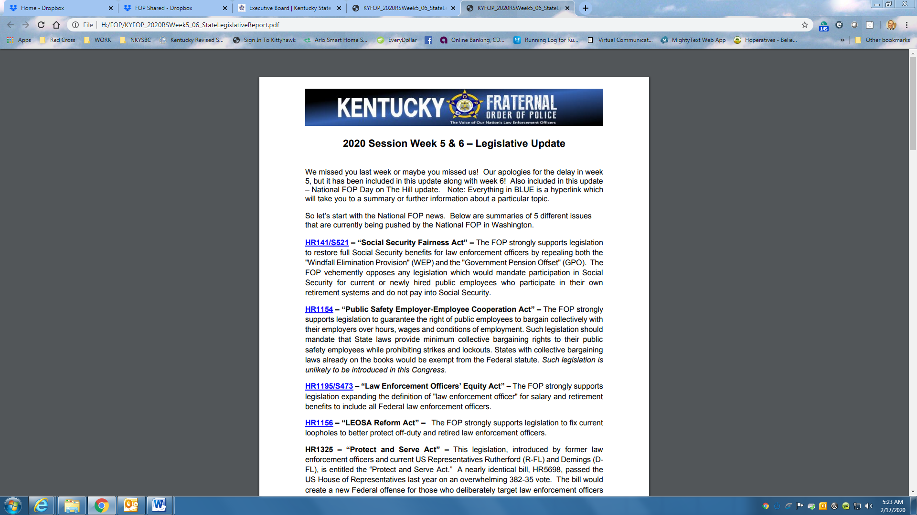

# State FOP Legislative Update

# Executive Board Elections

Nominations for Executive Board will be accepted at the November meeting. The election of the Executive Board will be held in December. In accordance with Section 5 of our current bylaws, we will hold elections for the following offices:

* President
* Vice President
* Secretary
* Treasurer
* Second Vice President
* Sergeant at Arms
* Chaplain
* State Lodge Trustee

Additionally, we have added a position of Immediate Past President. When a new President is elected, the outgoing President will assume the position of Immediate Past President. The Immediate Past President will serve as an advisor the Executive Board on all matters and will hold a vote on the Executive Board.

All elected Executive Board positions serve for two years, and will assume their office in January. Previously, the Secretary and Treasurer were combined into one position. This is a lot of responsibility for one person, so we have decided to separate these offices.  
  
If you have any questions about the duties or responsibilities of these positions, please contact a member of the Executive Board.

# Upcoming Events

Due to COVID-19, most of our regular events have been cancelled for 2020. We have resumed holding our monthly meetings.

Regular Lodge Meeting September 21 at 7 p.m.

Regular Lodge Meeting October 19 at 7 p.m.

Regular Lodge Meeting  
-Executive Board Nominations November 16 at 7 p.m.

**Executive Board Election Voting** December 21 – Time TBD

**Regular Lodge Meeting**-Election Results Announced December 21 at 7 p.m.